Safe Bunsen Burner Use General Guidelines

General Guidelines are an essential component of the University of Regina’s Health & Safety Management System. This general guideline has been created to provide a set of Do’s & Don’ts on how to use a Bunsen burner. It is expected that the general guidelines will assist in the creation of a lab-specific Safe Operating Procedure.

All general guidelines along with the related Safe Operating Procedures pertaining to you or your group’s activities should be kept in a location central to the work being performed and readily available to the individuals involved in the task.

Natural Gas Bunsen Burners
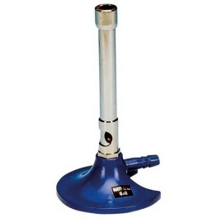
Bunsen burners are commonly used for heating (e.g., distillation, fixing cells onto slides) and sterilization (e.g., sterilizing inoculations loops).

- Bunsen burners present fire hazards. Place the Bunsen burner away from any overhead shelving, equipment, or light fixtures by at least 12 inches.
- Remove all papers, notebooks, combustible materials, and excess chemicals from the area.
- Tie-back any long hair, dangling jewelry, loose clothing.
- Before each use inspect hose for cracks, holes, pinch points, or any defects. Ensure the hose fits securely on the gas valve and burner.
- Like with all equipment, preventative maintenance is crucial. Test for hose leaks by spreading slightly watered-down dish soap or Snoop on the hose and watch for bubbles forming once you turn on the gas.
- Notify others in the lab that the burner will be in use.
- Use a sparker/ lighter with extended nozzle to ignite the burner. Never use a match.
- Adjust the flame by turning the collar to regulate airflow and produce an appropriate flame for the experiment (usually a medium blue flame).
- Do not leave flame unattended and never leave the lab while the burner or gas is on.
- If you smell natural gas in the area you may have a leak, immediately shut off gas, leave area, and contact Campus Security at 306.585.4999 or Health, Safety & Wellness at 306.585.4776.
- Shut off gas when its use is complete.
- Allow the burner to cool before handling. Ensure that the main gas valve is off before leaving the lab.
- Aerosolization of infectious materials can occur when inoculation loops are sterilized in the open flame of a Bunsen burner; therefore, microincinerators, electric Bunsen burners, or disposal loops are recommended as alternatives.
- Sustained open flames are prohibited inside biological safety cabinets because of the disruption of airflow patterns and potential for damaging the filters. When suitable non-flame alternatives are not available, touch-plate microburners that provide a flame on demand may be used.

Alternatives to Natural Gas Bunsen Burners
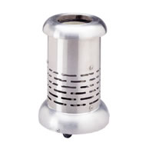
Electric Bunsen Burners
- An electric Bunsen burner combines the efficiency of a gas burner with the safety and control of an electric heater. (For an example, see: http://www.daigger.com/store/electric-bunsen-burner3540/19255?section=21).
- When used in a biological safety cabinet, an electric Bunsen burner should be placed at the rear to help minimize disruption of the air curtain at the front of the cabinet.

Microincinerators
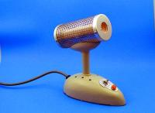
- Microincinerators are often equipped with shields to minimize the dispersal of aerosols. (For an example, see: https://us.vwr.com/store/catalog/product.jsp?catalog_number=101412-622#header. This Bact-cinerator sterilizes loops and needles safety and conveniently by preventing infectious spatter and/or cross contamination. It also safeguards personnel from an open flame or hazardous gas.)
- When used in a biological safety cabinet, the equipment should be placed at the rear of the cabinet to help minimize disruption of the air curtain at the front of the cabinet.

Disposable Loops and Inoculating Needles
- Single-use disposable loops are sterile and can be used in a biological safety cabinet as an alternative to reusable loops requiring sterilization with a burner or microincinerator. However, they will add to the amount of waste requiring decontamination.
- Disposable loops should be placed in a leak-proof, puncture-resistant waste container immediately after use.

