For full instructions and terminology see the Converis Ethics Module Instructions – Reviewer
Getting Started
Click https://uregina.converis.clarivate.com/ to log into Converis with Novell credentials. Community members will have been provided login credentials in an e-mail from Clarivate.

Once logged in, users are taken to the Dashboard, containing basic information about the user, their role, an “inbox” of items requiring attention, menu items for viewing records the user has access to, and the ability to create new content.

Changing Role: The user’s role is indicated in the top right corner. To review REB applications, select the “Reviewer Role”.

Click on the beside your name
Click on “Switch Role”
Click on “Ethics Reviewer Name”

Locating Applications for Review

Click on “REB”
Click on “REB Application”
Do not click on “REB Review Sheets”

Click on “View/Edit” to review the application

Reviewing an Application

There are 4 tabs that will require review

“Form Part 1”, “Form Part 2”, “Declaration” and the “Review” tab (found under “More”).

Uploading a Review: Click on the “Review Tab” click on the pencil icon to the right of your name.
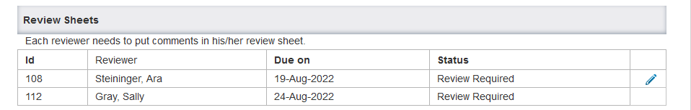
This will open your review sheet.

Upload comments on the application by clicking on the folder. Use the previous template provided or a word document.

Click on “Done” to save the Review Sheet

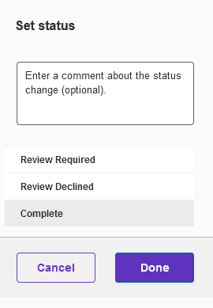

Select status “Complete” (for the Review Sheet)
Click on “Done”

This will return the user to the “Review” tab of the application

Click on “Save and Close” (for the Application)

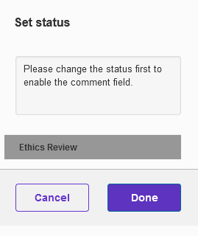

The status should remain “Ethics Review”
Click on “Done” (for the Application)

To confirm, check that the REB Application is no longer listed under “Things to do” on the Dashboard.
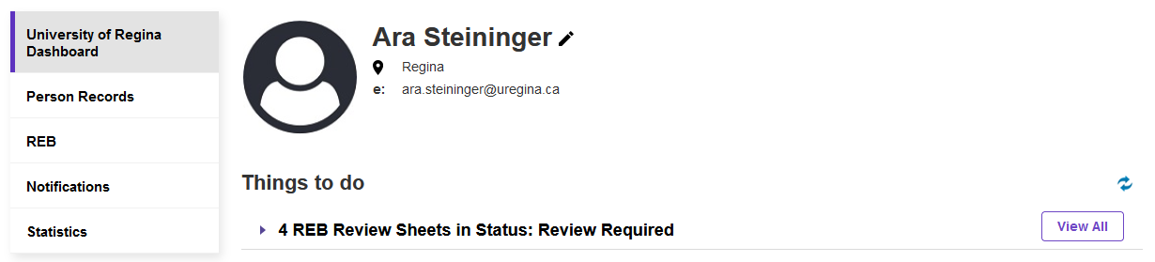

For any support, questions or to provide feedback, please contact:
Research.Ethics@uregina.ca
306-585-4775

