Email Communications to Participants
Re: Using FILR to share
Summary Report from Focus Group(s)
NOTE TO RESEARCHERS (remove this section from the email communication):
When setting up a FILR folder to share with a participant:
- If you use the participant’s name as the folder name, please de-identify once the Summary Release Form is returned.
- Set the appropriate time period for sharing the folder
- Set the participant role as a Collaborator in order for them to make changes to the documents.

(a) Initial email
Subject line: [not linked to a research study]

Dear Study Participant,
Thank you again for participating in the focus group for the study titled, “XXX”.
Please find attached the summary report from the focus group for you to review. While we cannot go back and add to or remove language from the focus group itself, I would like to solicit your feedback regarding the analysis of the conversation. In your opinion, is the interpretation of the discussion accurate, or would you like to propose any changes to the document?
I will use the University of Regina’s secure, file-sharing application, FILR, to share the summary and the Summary Release Form with you. You will receive an email inviting you to access the FILR folder. Just click on the link, which will take you to a registration page where you will need to identify a password to enter your folder. Please save your password in a safe place to remind yourself what it is.
Then follow these steps:
- Open the folder by clicking on [your name/pseudonym]. Inside you will see two Word files – one titled Summary[your initials].doc the other Summary Release Form[your initials].doc.
- As you scroll the cursor over the file name you will see a symbol to download the file . Open the downloaded files onto your computer.
- If you wish to make changes or deletions to the summary, or if you have additional comments, please add them to the document using comments or track changes. Once you are satisfied with the summary, I request that you sign, or indicate your agreement on, the Summary Release Form.
Finally, please upload the files by clicking on the upload symbol in the upper right corner of the page. You will then need to click Overwrite File in the message box that will appear in the lower left corner of the screen.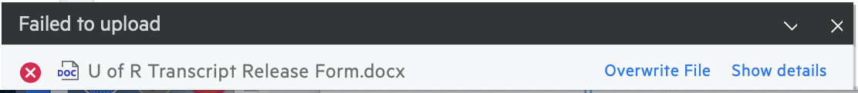

I would appreciate receiving your comments within (timeframe; e.g., 1 week). If you do not have any changes to suggest, please email me stating you approve of the summary (using XXX in the subject line). If I do not hear back from you within this time frame, I will reach out to you again one more time.

Sincerely,
PI/RA’s signature

(b) Reminder email
Subject line: [not linked to a research study]
Dear Study Participant
Just a friendly reminder that I recently sent you the summary of our focus group through a FILR link. Feel free to contact me if you have any difficulties with this process.
It would be appreciated if I could receive your comments within (timeframe; e.g., 1 week). If you do not have any changes to suggest, you can either email me stating you approve of the summary (using XXX in the subject line) or update the Summary Release Form file on FILR. As was stated in the consent form, if I do not hear from you after this time period, I will include your information in the overall analyses.
Sincerely,
PI/RA’s signature

