Workstation Virtual Ergonomics: Self-Assessment Checklist

Thank you for requesting a virtual ergonomic assessment. In order to provide you with a workstation that offers optimal comfort and performance while working remotely, we ask that you complete this self-assessment PRIOR to receiving confirmation of a virtual ergonomic assessment. Please email your completed assessment to health.safety@uregina.ca. Our Healthy Workplace Advisor, Kelsey Malakoff, will review your self-assessment and contact you to discuss the results and/or to book a virtual ergonomic assessment, if required.
If you have any questions, please contact 306 337 3269.

Office Chair |  | Home | Office | If from your chair is from your office on campus, please indicate your office location ie: AH 444 | Notes
1. | Is the office chair you are using now, yours or from your office on campus?
 |  | Yes | No | Are you experiencing any discomfort?  If so, please explain | Suggested Actions
2. | Are your feet fully supported by the floor when you are seated? |  |  |  | - Lower the chair  - Use a footrest  Obtain lumbar roll
3. | Do your armrests allow you to get close to your workstation? |  |  |  | - Adjust armrests  - Remove armrests
4. | Does your chair provide support for your lower back? |  |  |  | - Adjust your chair back  - Obtain proper chair  - Obtain lumbar roll
5. | When your back is supported, are you able to sit without feeling pressure from the chair seat on the back of your knees? |  |  |  | - Adjust seat pan  - Add a back support
6. | Can the height, seat and back of the chair be adjusted to achieve the posture outlined below? |  |  |  | - Obtain a fully adjustable chair
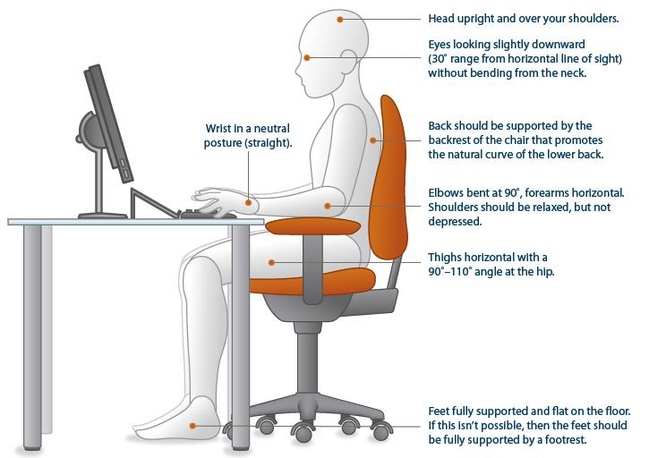
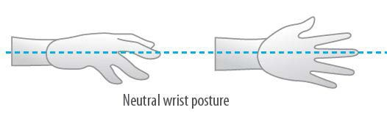

Keyboard and Mouse |  | Home | Office | If from keyboard/mouse is from your office on campus, please indicate your office location ie: AH 444 | Notes
7. | Is the keyboard/mouse you are using now, yours or from your office on campus?
 |  | Yes | No | Are you experiencing any discomfort? If so, please explain | Suggested Actions
8. | Are your keyboard, mouse and work surface at your elbow height? |  |  |  | - Raise / lower workstation  - Raise or lower keyboard  - Raise or lower chair
9. | Are frequently used items within reach? |  |  |  | - Rearrange workstation
10. | Is the keyboard close to the front edge of the desk allowing space for the wrist to rest on the desk surface? |  |  |  | - Move keyboard to correct position
11. | When using your keyboard and mouse, are your wrists straight and your upper arms relaxed? The keyboard should be flat and not propped up on keyboard legs as an angled keyboard may place the wrist in an awkward posture when keying. |  |  |  | - Re-check chair, raise or lower as needed  - Check posture  - Check keyboard and mouse height
12. | Is your mouse at the same level and as close as possible to your keyboard? |  |  |  | - Move mouse closer to keyboard  - Obtain larger keyboard tray if necessary
13. | Is the mouse comfortable to use? |  |  |  | - Rest your dominant hand by using the mouse with your non-dominant hand for brief periods (mouse buttons can be changed within the computer control panel  - Investigate alternate mouse options.

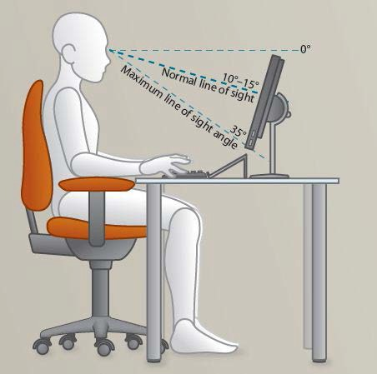
Monitor and Work Surface |  | Home | Office | If the monitor(s) is from your office on campus, please indicate your office location: ie: AH 444 experiencing any discomfort? If so, please explain | Notes
14. | Is the monitor(s) you are using now, yours or from your office on campus?
 |  | Yes | No | Are you experiencing any discomfort? If so, please explain | Suggested Actions
15. | Is your monitor positioned directly in front of you? |  |  |  | - Reposition monitor
16. | Is your monitor positioned at least an arm’s length away?  Note: the monitor’s location is dependent on the size of the monitor, the font, screen resolution and the individual user e.g. vision/use of bifocal spectacles etc. |  |  |  | - Reposition monitor  - Seek an alternative monitor if necessary e.g. flat screen that uses less space
17. | Is your monitor height slightly below eye level? |  |  |  | - Add or remove monitor stand  - Adjust monitor height
18. | Is your monitor and work surface free from glare? |  |  |  | - Windows at side of monitor  - Adjust overhead lighting  - Cover windows  - Obtain antiglare screen
19. | Do you have appropriate light for reading or writing documents? |  |  |  | - Obtain desk lamp  - Place on left if right- handed – place on right if left handed
20. | Are frequently used items located within the usual work area? Items which are only used occasionally should be in the occasional work area. |  |  |  | - Rearrange workstation
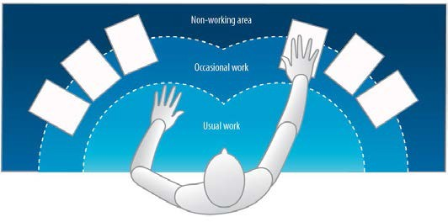

Breaks |  | Yes | No | If not, why? | Notes
21. | Do you take postural breaks every 30 minutes?  Ex. standing, walking to printer / fax etc.? |  |  |  | - Set reminders to take breaks
22. | Do you take regular eye breaks from looking at your monitor? |  |  |  | - Refocus on picture on wall every 30 minutes
Accessories |  | Yes | No | If not, why? | Notes
23. | Is there a sloped desk surface or angle board for reading and writing tasks if required? |  |  |  | - Obtain an angle board
24. | Is there a document holder either beside the screen or between the screen and keyboard if required? |  |  |  | - Obtain document holder
25. | Are you using a headset or speakerphone if you are writing or keying while talking on the phone? |  |  |  | - Obtain a headset if using the phone and keyboard

Self-Assessment completed by:
Name: |  | Date:
Faculty: |  | Employee ID #:
HEALTHY WORKPLACE ADVISOR TO COMPLETE THIS SECTION
Virtual Assessment Required: |  | Recommendation:
Comments:

