Faculty of Kinesiology and Health Studies

**SPORTS FOR ALL**

Invites applications for the position of

**INSTRUCTOR**

For Fall 2021

Part time positions available

**DUTIES & RESPONSIBILITIES:**

Reporting to the Coordinator, Student and Youth Programming or designate, the successful applicant will be responsible for providing leadership, instruction and supervision of children ages 7-13 with intellectual disabilities and/or developmental disabilities. The successful applicant will work in a team environment to provide programming to members of the University community.

**INSTRUCTOR DUTIES:**

* Facilitate sport and recreational activities for a group of children
* Adapt activities to meet the needs of the participants
* Work as part of a team implementing children’s programs

**PROGRAM DESCRIPTION:** This **8-week** program will focus on the development of FUNdamental movement skills. To promote participation in physical activity.  These skills will be practiced in a variety of games and activities. Team sports will also be introduced to facilitate the successful transfer of these skills into community-based activities, including physical education. The low instructor to athlete ratio will allow for individualized instruction to provide everyone with a fun and successful learning experience.

**QUALIFICATIONS:**

* Must be a University of Regina student. Preference provided to those students registered in the Faculty of Kinesiology and Health Studies or the Faculty of Education
* Must have experience working with children
* Must be familiar with teaching/coaching children in sport activities
* Must be enthusiastic, creative, demonstration strong leadership skills, have excellent organization and communications skills
* CPR and First Aid preferred
* Vulnerable Sector Police Record Check required
* Must be available to work Monday nights (Program runs from 5:30 p.m. – 7:30 p.m.)

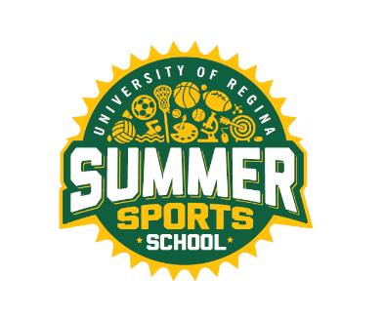

**SALARY:** $16.00/hour

**HOW TO APPLY:** Submit cover letter and resume to:



Brooke Platt

Student and Youth Programming, Student Assistant

intramurals@uregina.ca

**CLOSING DATE: 11:59 p.m. on Tuesday, September 21, 2021**

Employment and training will begin October 4th , 2021