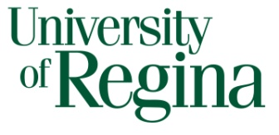
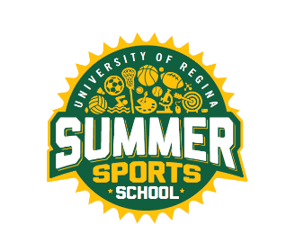
SUMMER EMPLOYMENT OPPORTUNITIES

Faculty of Kinesiology and Health Studies
RECREATION SERVICES

Invites applications for

SUMMER SPORTS SCHOOL
for the summer of 2023

Positions: Aquatics Instructor

Full and part-time positions available

Terms: June 26th – August 25th, 2023
Monday to Friday
Full time: 7 hours/day
Part-time: 3.5 hours/day
(Times may vary slightly)

Duties: To provide leadership, instruction, and supervision of children in various activities and sports. Coordinate various aquatic games and activities for the children. Instruct community swim lessons (Red Cross Swim Kids Program) in the morning as assigned.

Requirements: MUST:
- Be at least 16 as of June 1, 2023
- Have related field work experience
- Be enthusiastic and creative
- Demonstrate strong leadership skills
- Have excellent organization and communication skills
- Work well with children
- Be willing to be in the pool everyday
- Have CPR/First Aid
- Red Cross Swim Kids Teachers Certificate
- NLS preferred

- Criminal Record Check

How to Apply: Drop off a cover letter and résumé to:

Brooke Platt
Community Program Assistant
Intramurals Sports Office
Room CK 172, Centre for Kinesiology Health and Sport
University of Regina
Regina, SK
S4S 0A2

Or send via email to khs.youth-programs@uregina.ca

Closing Date: 11:59 p.m. Tuesday, March 1st, 2023 or until positions are filled

The University of Regina is committed to employment equity.
We encourage applications from all qualified applicants.

