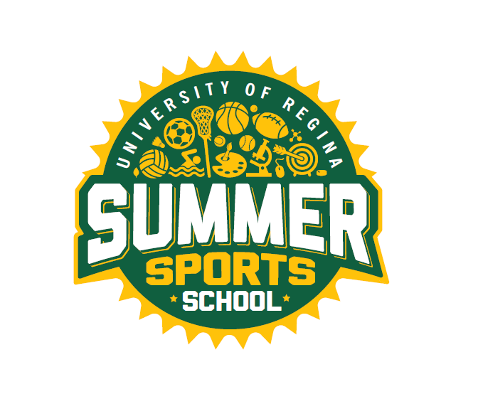

SUMMER EMPLOYMENT OPPORTUNITIES
Faculty of Kinesiology and Health Studies
RECRATION SERVICES

Invites applications for

SUMMER SPORTS SCHOOL
for the summer of 2023

Positions: Science Camp Coordinators

(Part-time position available)

Terms: June 26th – August 25th, 2023
Monday to Friday
Part-time: 5hrs/daily
(Times may vary slightly)

Duties: Plan, develop and execute the delivery of fun, safe, and challenging activities for youth ages 7-12 years as part of science activities for Summer Sports School. Other duties as required.

Requirements: MUST:
- Be a returning student in the Fall
- Preference to those in the Faculty of Education and the Faculty of Science
- Have related field work experience
- Be enthusiastic and creative
- Demonstrate strong leadership skills
- Have excellent organization and communication skills
- Able to plan a variety of science activities
- Work well with children
- Have CPR/First Aid
- Criminal Record Check

How to Apply: Drop off a cover letter and résumé to:

Brooke Platt
Community Program Assistants
Intramurals Sports Office
Room CK 172, Centre for Kinesiology Health and Sport
University of Regina
Regina, SK
S4S 0A2

Or send via email to khs.youth-programs@uregina.ca

Closing Date: 11:59 p.m. Wednesday, March 1st, 2023 or until positions are filled

The University of Regina is committed to employment equity. We encourage applications from all qualified applicants.

