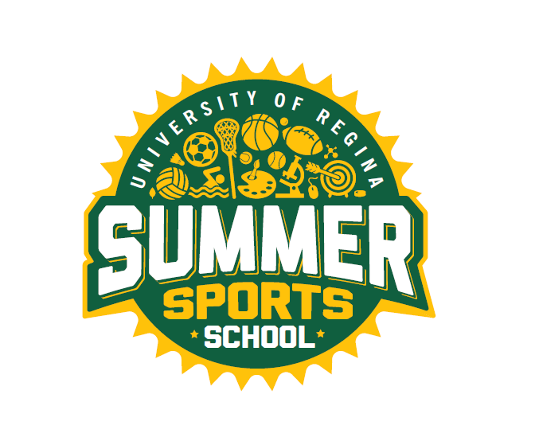

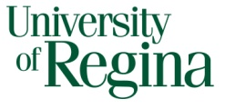
SUMMER EMPLOYMENT OPPORTUNITIES

Faculty of Kinesiology and Health Studies
RECREATION SERVICES

Invites applications for

SUMMER SPORTS SCHOOL
for the summer of 2023

Positions: Sports Instructors

Full and part-time positions available

Terms: June 26th – August 25th, 2023
Monday to Friday
Full time: 8 hours/daily
Part-time: 5 hours/daily
(Times may vary slightly)

Duties: To provide leadership, instruction, and supervision of children in various sport and recreational activities.

Requirements: MUST:
- Be a returning student in the Fall
- Preference to those in the Faculty of Education or the Faculty of Kinesiology & Health Studies
- Have related field work experience
- Be enthusiastic and creative
- Demonstrate strong leadership skills
- Have excellent organization and communication skills
- Plan a variety of sports and games
- Work well with children
- Have CPR/First Aid
- Criminal Record Check

How to Apply: Drop off a cover letter and résumé to:

Brooke Platt
Community Program Assistants
Intramurals Sports Office
Room CK 172, Centre for Kinesiology Health and Sport
University of Regina
Regina, SK
S4S 0A2

Or send via email to khs.youth-programs@uregina.ca

Closing Date: 11:59 p.m. Wednesday, March 1st, 2023 or until positions are filled

The University of Regina is committed to employment equity.
We encourage applications from all qualified applicants.

